**Program-3**

**A.1 Aim: To implement**

1. Design of static website with HTML5 and CSS tags

2. Understand CSS Box Model

3. Understand CSS properties- font, text, background

**A.2 Prerequisite:**

HTML

**A.3 Outcome:**

After successful completion of this experiment students will be able to

1. Understand and implement new HTML 5 tags and make web pages look better by adding CSS.

2. Implement CSS layouts as given below

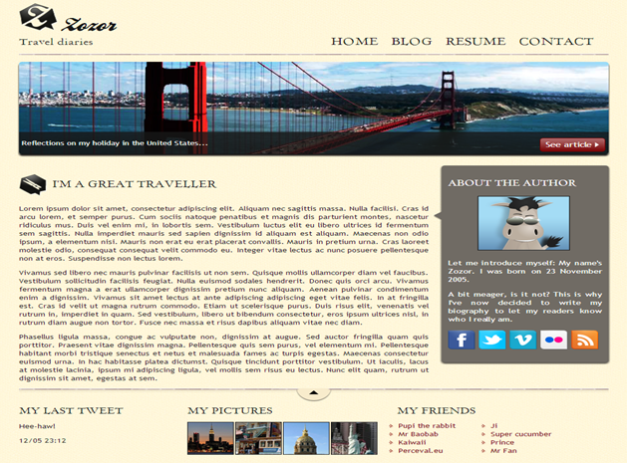

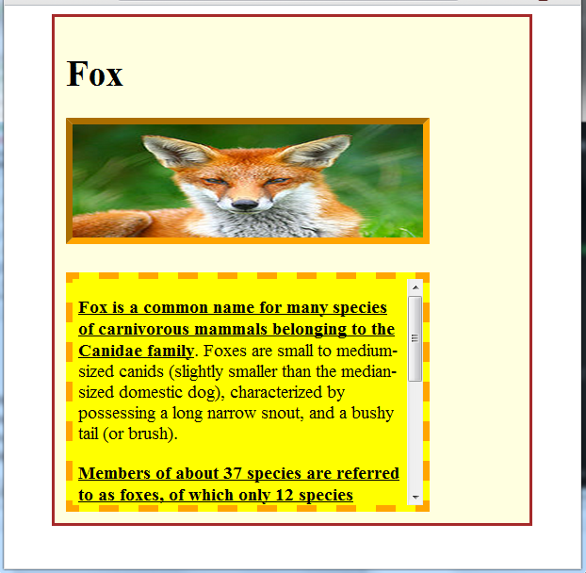

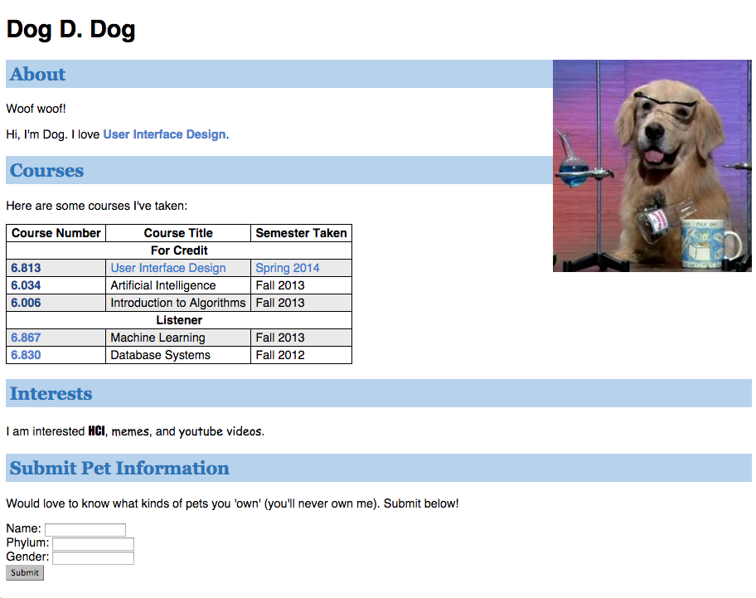

**A.4 Theory:**

* CSS is a language that describes the style of a HTML document.
* CSS describes how HTML elements should be displayed.
* CSS stands for Cascading Style Sheets
* CSS syntax

Selector , declaration

Ex: h1 Selector

{

font-size:12 Declaration

}

* 3 Types of CSS
  + Inline Style
    - CSS code written with the tag we want to apply style with
    - <h1 style="color:blue;margin-left:30px;">This is a heading</h1>
  + Internal Style
    - CSS code written in the head part of the html
    - <head>  
      <style>  
      body {  
          background-color: linen;  
      }  
        
      h1 {  
          color: maroon;  
          margin-left: 40px;  
      }   
      </style>  
      </head>
  + External Style
    - Css code written in external file and file name included in html head
    - <head>  
      <link rel="stylesheet" type="text/css" href="mystyle.css">  
      </head>

**Note: It is left to discretion of students to decide the topic to make website on. Also students are given freedom to learn more tags and implement it much better to improve UI of the web page.**

**PART B**

|  |  |
| --- | --- |
| Roll No.: E009 | Name: Dhrumil Burad |
| Class: B.tech CSBS | Batch: B1 |
| Date of Experiment: 12-01-2023 | Date of Submission:25-01-2023 |

**(PART B: TO BE COMPLETED BY STUDENTS)**

**(Students must submit the soft copy as per following segments within two hours of the**

**practical. The soft copy must be uploaded on the Blackboard or emailed to the concerned**

**lab in charge faculties at the end of the practical in case the there is no Black board access**

**available)**

# **B.1 Software Code written by student:**

# **(Students must paste the code here)**

# **Fox**

## **Html**

<!DOCTYPE html>

<html lang="en">

<head>

    <meta charset="UTF-8">

    <meta http-equiv="X-UA-Compatible" content="IE=edge">

    <meta name="viewport" content="width=device-width, initial-scale=1.0">

    <title>Fox page</title>

    <link rel="stylesheet" href="./fox.css">

</head>

<body>

    <h1>FOX</h1>

    <div class="dd">

        <img class=" foximg" src="./fox.jpeg" alt="fox image">

    </div>

    <div class="abt">

        <p>

            <strong>

                <u>

                    Foxes are small to medium-sized, omnivorous mammals belonging to several genera of the family

                    Canidae.They have a flattened skull, upright, triangular ears, a pointed, slightly upturned snout,

                    and long bushy tail (or brush).

                </u>

            </strong>

        </p>

        <p>

            Twelve species belong to the monophyletic "true foxes" group of genus Vulpes. Approximately

            another 25 current or extinct species are always or sometimes called foxes; these foxes are either part of

            the paraphyletic group of the South American foxes, or of the outlying group, which consists of the

            bat-eared

            fox, gray fox,and island fox.[1]

        </p>

        <p>

            Foxes live on every continent except Antarctica. The most common and widespread species of fox is the red

            fox (Vulpes vulpes) with about 47 recognized subspecies.[2] The global distribution of foxes, together with

            their widespread reputation for cunning, has contributed to their prominence in popular culture and folklore

            in

            many societies around the world. The hunting of foxes with packs of hounds, long an established pursuit in

            Europe, especially in the British Isles, was exported by European settlers to various parts of the New

            World.

        </p>

    </div>

</body>

</html>

## **CSS**

html {

*/* background-color: #0093E9; */*

    background-image: linear-gradient(163deg, #0093E9 6%, #80D0C7 72%);

    width: 100%;

    height: 100%;

}

.dd {

    display: flex;

    align-items: left;

    width: 50%;

    justify-content: left;

    margin: 20px;

}

img {

    width: 50%;

    height: 50%;

    border: 6px solid red;

}

.abt {

    overflow-y: scroll;

    background-color: #0093E9;

    border: 6px dashed orange;

    height: 200px;

    width: 500px;

    margin: 20px;

}

p {

    margin: 0px !important;

}

# **Dog D Dog**

## **Html**

<!DOCTYPE html>

<html lang="en">

<head>

    <meta charset="UTF-8">

    <meta http-equiv="X-UA-Compatible" content="IE=edge">

    <meta name="viewport" content="width=device-width, initial-scale=1.0">

    <title>Dog D. Dog</title>

    <link rel="stylesheet" href="./dogddog.css">

</head>

<body>

    <article class="leftsec">

        <h1 class="d">Dog D. Dog</h1>

        <img src="./dogddog.jpg">

        <section class="about">

            <h1 class="heads">About</h1>

            <div>Woof woof!</div>

            <div> Hi, I'm Dog. I love <a href="#" class="blucol">User Interface Design</a></div>

        </section>

        <section class="courses">

            <h1 class="heads">courses</h1>

            Here are some courses I've taken:

            <table>

                <tr>

                    <th>Course number</th>

                    <th>Course Title</th>

                    <th> Semester Taken</th>

                </tr>

                <tr>

                    <th colspan="3">For credit</th>

                </tr>

                <tr class="grbk">

                    <td><a class="blucol" href="#">6.813</a></td>

                    <td><a class="blucol" href="#">6.034</a></td>

                    <td><a class="blucol" href="#">6.006</a></td>

                </tr>

                <tr>

                    <td class="blucol">6.034</td>

                    <td>Artificial Intelligence</td>

                    <td> Fall 2013</td>

                </tr>

                <tr class="grbk">

                    <td class="blucol">6.006</td>

                    <td>Introduction to Algorithms</td>

                    <td>Fall 2013</td>

                </tr>

                <tr>

                    <th colspan="3">Listner</th>

                </tr>

                <tr class="grbk">

                    <td class="blucol">6.867</td>

                    <td>Machine Learning</td>

                    <td> Fall 2013</td>

                </tr>

                <tr>

                    <td class="blucol">6.830</td>

                    <td>Database Systems </td>

                    <td>Fall 2012</td>

                </tr>

            </table>

        </section>

        <section class="interests">

            <h1 class="heads">Interests</h1>

            <div>I am interested <span class="f1">HCI </span>,<span class="f2">memes</span>, and <span

                    class="f2">youtube

                    videos.</span></div>

        </section>

        <section class="sub" id="">

            <h1 class="heads">Submit Pet Information</h1>

            <div>Would love to know what kinds of pets you 'own' (you'll never own me). Submit below</div>

            <br>

            <form>

                Name:<input type="text"><br>

                Phylum:<input type="text"><br>

                Gender:<input type="text"><br>

                <button type="submit">Submit</button>

            </form>

        </section>

    </article>

</body>

</html>

## **CSS**

.leftsec {

    position: relative;

    float: left;

}

.d {

    font-size: 40px;

}

img {

    position: absolute;

    left: 50vw;

}

.heads {

    background-color: #b6d2ec;

    color: #2a75ba;

    font-size: 27px;

    padding: 5px;

}

.blucol {

    color: #2a75ba;

    text-decoration: none !important;

    font-weight: bold;

}

.about a {

    text-decoration: none;

    font-weight: bold;

}

section {

    font-size: 18px;

}

table,

th,

tr,

td {

    border: 2px solid black;

    border-collapse: collapse;

    padding: 5px;

}

.grbk {

    background-color: #eaeaea;

}

.f1 {

    font-family: Impact, Haettenschweiler, 'Arial Narrow Bold', sans-serif;

}

.f2 {

    font-family: "comic sans MS";

}

# **Zozor**

## **Html**

*<!-- header : nav bar*

*footer dic tag*

*section- article*

*aside*

*-->*

<!DOCTYPE html>

<html lang="en">

<head>

    <meta charset="UTF-8">

    <meta http-equiv="X-UA-Compatible" content="IE=edge">

    <meta Friend="viewport" content="width=device-width, initial-scale=1.0">

    <title>Zozor</title>

    <link rel="stylesheet" href="./zozor.css">

</head>

<body link="red">

    <div class="main_wrp">

        <header>

            <div class="zlogo">

                <img src="./zozor_logo.png">

                <h3> Zozor</h3>

            </div>

            <span>Travel Diaries</span>

            <nav class="navbar">

                <a href="#" class="active">HOME</a>

                <a href="#">BLOG</a>

                <a href="#">RESUME</a>

                <a href="#">CONTACT</a>

            </nav>

        </header>

        <div class="line"> </div>

        <div class="banner">

            <div class="btxt"> Reflections on my holiday in the United States... </div>

            <button class="rb">See article</button>

        </div>

        <section>

            <article class="a1">

                <section CLASS="a1s1">

                    <img src="./pin.png">

                    <h3 class="trv">I'M A GREAT TRAVELLER</h3>

                </section>

                <div>Lorem ipsum dolor sit amet.</div>

                <div>Lorem ipsum dolor sit amet consectetur adipisicing elit. Ea, fuga?</div>

                <div>Lorem ipsum dolor sit amet consectetur adipisicing elit. Atque, temporibus dolores! Similique

                    consectetur quos iste?</div>

            </article>

            <aside class="aside">

                <h1>ABOUT THE AUTHOR</h1>

                <img class="aar" src="./arrow.png">

                <p><img class="zzr" src="./zozor.png"></p>

                <div>Lorem ipsum dolor sit amet consectetur adipisicing elit. Consequatur, magnam.</div>

                <br>

                <div>Lorem ipsum dolor sit amet consectetur adipisicing elit. Consequatur, magnam.</div>

                <br>

                <div>Lorem ipsum dolor sit amet consectetur adipisicing elit. Consequatur, magnam.</div>

                <p class="smlog">

                    <img src="./facebook.png">

                    <img src="./flickr.png">

                    <img src="./vimeo.png">

                    <img src="./twitter.png">

                    <img src="./rss.png" </p>

            </aside>

        </section>

        <footer>

            <div class="tw">

                <h1>MY LAST TWEET</h1>

                <p>Hee-Haw!</p>

                <p>18-01-2023 11:43</p>

            </div>

            <div class="pic">

                <h1>MY PICTURES</h1>

                <div class="pics">

                    <img src="./pic1.jpg" alt="">

                    <img src="./pic2.jpg" alt="">

                    <img src="./pic3.jpg" alt="">

                    <img src="./pic4.jpg" alt="">

                </div>

            </div>

            <div class="frnds">

                <h1>MY FRIENDS</h1>

                <ul>

                    <li>Friend 1</li>

                    <li>Friend 2</li>

                    <li>Friend 3</li>

                    <li>Friend 4</li>

                </ul>

                <ul>

                    <li>Friend 5</li>

                    <li>Friend 6</li>

                    <li>Friend 7</li>

                    <li>Friend 8</li>

                </ul>

            </div>

        </footer>

    </div>

</body>

</html>

## **CSS**

html {

    width: 100%;

    height: 100%;

}

body {

    width: 100%;

    height: 100%;

    background-color: beige;

    margin-left: 50px;

    margin-right: 50px;

}

*/* .main_wrp {*

*position: absolute;*

*align-items: center;*

*height: 100%;*

*width: 80%;*

*margin: auto;*

*/* display: block; */*

*/* position: relative;*

*}*

*\*/*

.zlogo {

    display: flex;

    flex-direction: row;

    font-size: 40px;

}

h3 {

    margin-top: 10px;

    margin-bottom: 0px;

    padding-left: 6px;

}

span {

    font-size: 20px;

}

.navbar {

    display: flex;

    font-size: 25px;

    position: absolute;

    top: 15vh;

    right: 10vw;

}

a:hover {

    text-decoration: underline;

    color: rgb(255, 255, 255);

    background-color: rgb(14, 13, 13);

}

a {

    padding: 8px;

    text-decoration: none;

}

.line {

    background-image: url(./line.png);

    height: 4px;

    background-repeat: repeat-x;

    width: 90%;

    position: absolute;

    top: 20vh;

}

.banner {

    height: 200px;

    width: 80%;

    border: 0px solid;

    background-image: url(./sanfrancisco.jpg);

    border-radius: 20px;

    box-shadow: 0px 4px 4px #1c1a19;

    background-repeat: no-repeat;

    background-size: cover;

    position: absolute;

    top: 26vh;

    margin-left: 100px;

}

.btxt {

    position: absolute;

    bottom: 0;

    right: 0;

    width: 99%;

    height: 33px;

    padding-top: 15px;

    padding-left: 10px;

*/* height: 35px; */*

    border-radius: 0 0 20px 20px;

    color: aliceblue;

    background-color: rgba(42, 40, 40, 0.8);

*/* padding-left: 4px; */*

}

.rb {

    position: absolute;

    bottom: 15px;

    right: 15px;

    height: 25px;

    background-color: rgb(168, 5, 5);

    color: aliceblue;

    background-image: url(./small_arrow.png);

    background-repeat: no-repeat;

    background-position: right;

    padding-right: 10px;

    border-radius: 5px;

*/* padding-right: 10px; */*

}

.a1 {

    position: absolute;

    top: 60vh;

*/* display: inline-block; */*

    left: 10vw;

    position: absolute;

    top: 60vh;

}

.a1 div {

    padding: 5px;

}

.a1s1 {

    display: flex;

    flex-direction: row;

}

.trv {

    margin-top: 30px;

}

.aside {

    background-color: #706B64;

    position: absolute;

    top: 63vh;

    right: 30vh;

    width: 20vw;

*/* height: 60vh; */*

    padding: 10px;

    text-align: justify;

    color: aliceblue;

    border-radius: 5px;

    font-family: 'Trebuchet MS', 'Lucida Sans Unicode', 'Lucida Grande', 'Lucida Sans', Arial, sans-serif;

    box-shadow: 0px 8px 10px black;

}

.aside p {

    text-align: center;

}

.zzr {

    border: 2px solid black;

}

.aar {

    position: relative;

    right: 1.5vw;

}

.smlog img {

    border: 2px solid black;

    border-radius: 0 8px 0 8px;

}

footer {

    background: url(top.png) no-repeat top center, url(./line.png) repeat-x;

    padding-top: 0px;

    position: absolute;

    top: 135vh;

    width: 80%;

}

.tw,

.pic,

.frnds {

    display: inline-block;

    vertical-align: top;

    margin: 55px;

    margin-top: 0px;

}

.tw h1,

.pic h1,

.frnds h1 {

    font-size: 25px;

    font-style: normal;

}

.frnds ul {

    margin-top: 0px;

    list-style-image: url(./external_link.png);

    display: inline-block;

    vertical-align: top;

    color: #760001;

}

# **B.2 Input and Output**

# **(Students must paste input and output here)**

# **Fox**

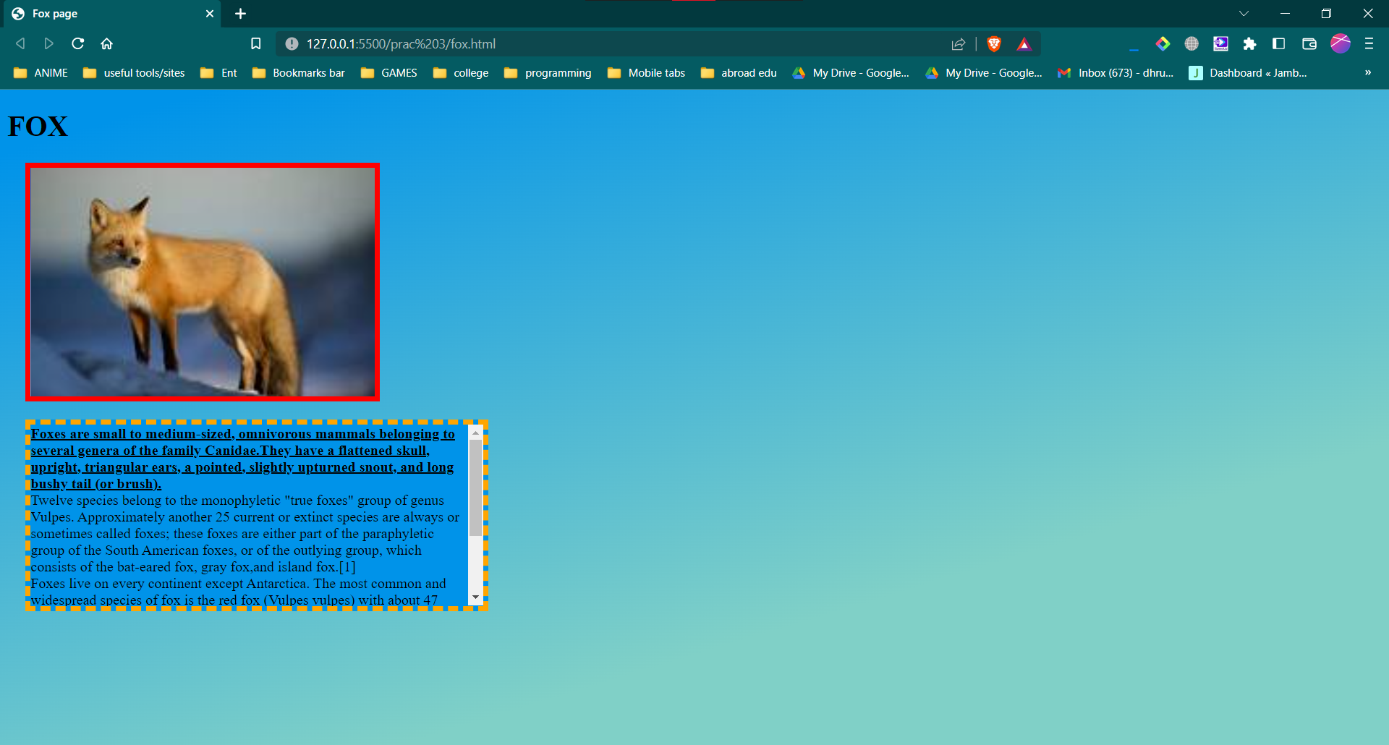

# **Dog D Dog**

## **Screenshot**

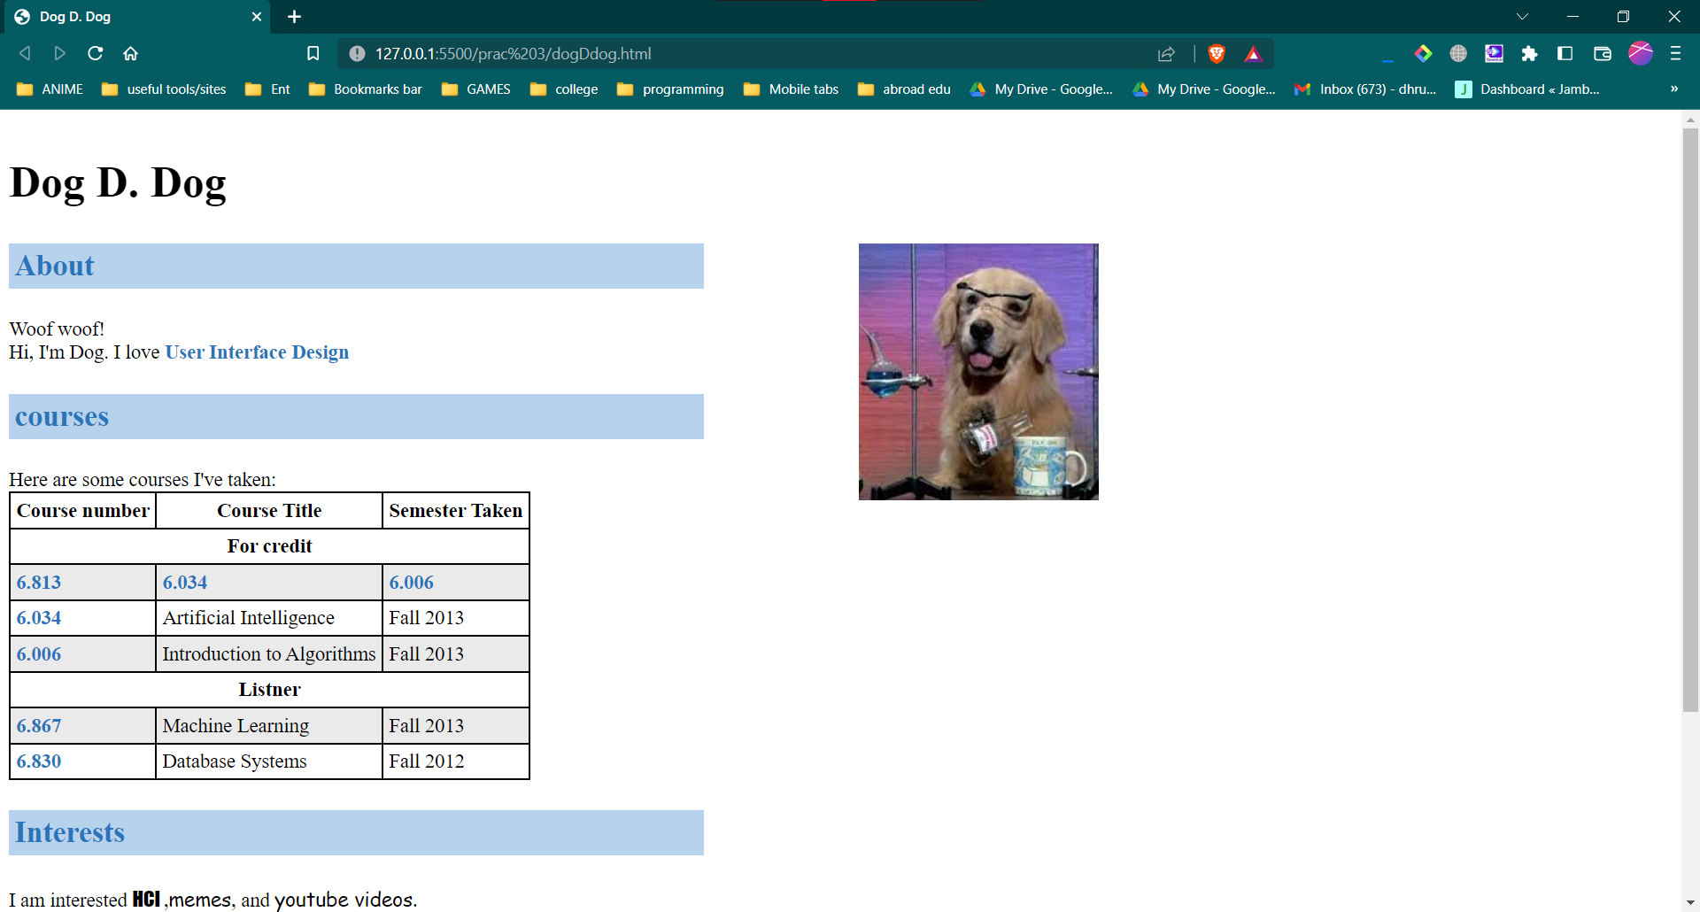

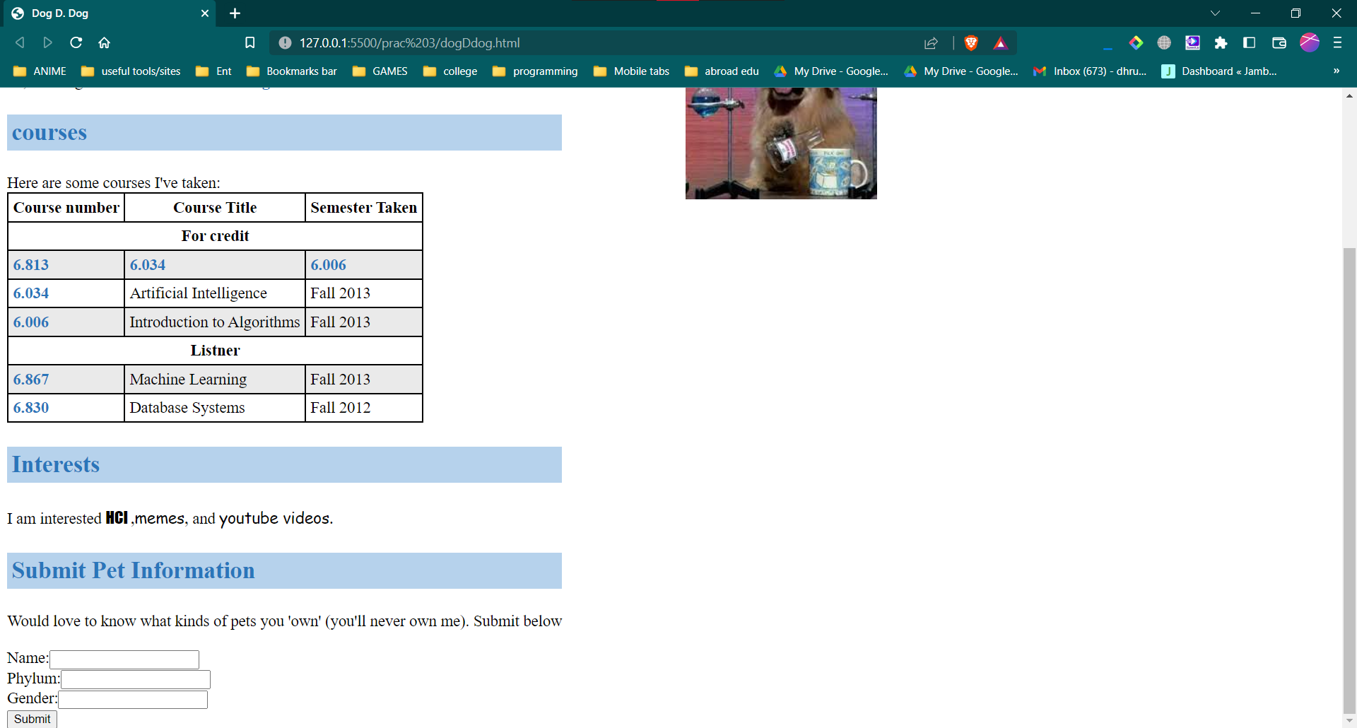

# **Zozor**

## **Screenshot**

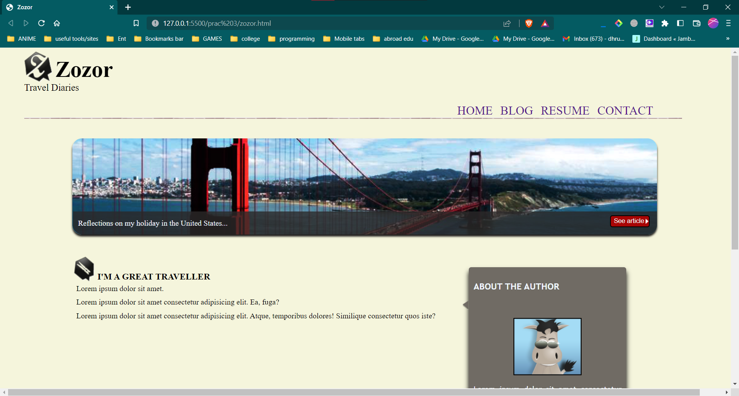

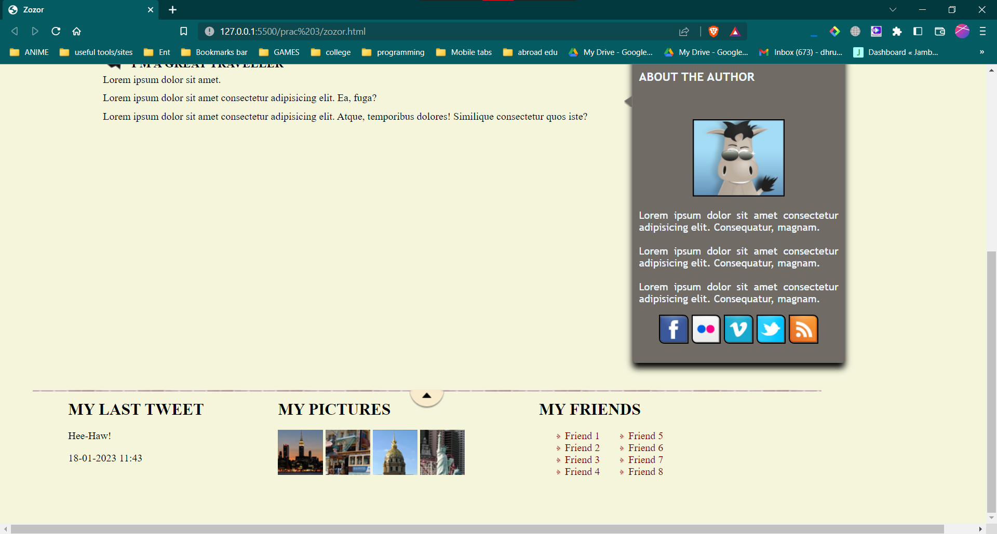

## **B.3. Observations and Learning**

# **(Students are expected to comment on the output obtained with clear observations and learning for each task/ sub part assigned**

Learnt how to design static websites by using and implementing HTML5 tags. Also learnt how to use CSS properties like box-model, font, text, background

# **B.4. Conclusion**

# **(Students must write the conclusion as per the attainment of individual outcome listed above and learning/observation noted in Sec. B.3)**

Designed the website layouts given using HTML5 and CSS tags. Understood CSS Box model and properties